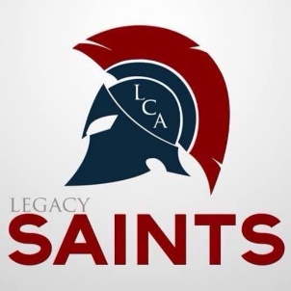
Legacy Christian Academy
5933 Valley Pike, Stephens City, VA 22655

Transcript/Recommendation Request Form

Transcript Information

Name: __________________________________________________________________
College Requesting Transcript: _______________________________________________
College Address: __________________________________________________________
City: ______________________________________ State: _________ Zip: ___________
College Email: ____________________________________________________________
College Fax Number: ___________________________________

Recommendation Letter
College Requesting the Recommendation Letter: _________________________________
How does the document need to be sent? Mail Email Fax (Be sure to include the necessary information
For us to send the document in the manner is which it is to be sent.)
Is there a deadline? Yes No Deadline Date: ______________

Please Note: LCA will send five transcripts to colleges with no charge. After the 5th request, the school will charge $3.00/document. Transcript and Recommendation letters will be available after 5-7 business days.

