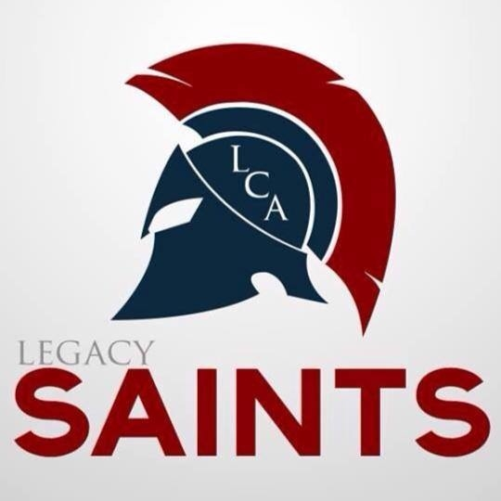

LCA Internship Proposal Form
Submit completed proposal to the Mr. Reisberg by February 17, 2023

Student’s Name: _____________________________________________________ Grade: ________
Name of Proposed Company: __________________________________________________________
Internship Supervisor’s Name: _________________________________________________________
Company Address: __________________________________________________________________
__________________________________________________________________________________
Work Phone: _________________________ Supervisor’s Email: ____________________________
Agreed upon dates and hours: _________________________________________________________
Description of the work student will perform:

Description of the work student will observe:

Approval Signatures

“I understand the purpose and standards for the Legacy Christian Academy High School Internship Program and hours and description of the proposed work for the student named above and agree to help the student fulfill these goals.”

Internship Supervisor’s Signature: _____________________________ Date: ______________________

“I understand the Legacy Christian Academy High School Internship Program, including the hours and description of the proposed work for my child named above. I agree to help my child fulfill these goals and my signature gives my consent and approval for his/her participation.”

Parent’s Signature: __________________________________________ Date: _____________________

Principal’s Signature of Internship Approval: _______________________________ Date: ___________

