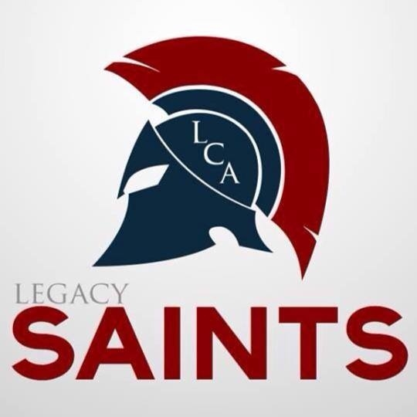
Legacy Christian Academy
Intern Evaluation Form

Student: _______________________________________
Evaluated By:_____________________ Date: ________

SCALE: 1 = UNACCEPTABLE 2 = NEEDS IMPROVEMENT 3 = SATISFACTORY
4 = VERY GOOD 5 = SUPERIOR

Punctuality (Beginning of day? Breaks?) 1 2 3 4 5
Comments:

Motivation (Energetic? Take Initiative?) 1 2 3 4 5
Comments:

Attitude Toward Tasks (Responsible? Eager to Serve?) 1 2 3 4 5
Comments:

Attitude Toward Supervisor (Respectful? Cooperative?) 1 2 3 4 5
Comments:

Quality of Work (Neat? Organized? Thoughtful?) 1 2 3 4 5
Comments:

Quantity of Work (Meet your expectations?) 1 2 3 4 5
Comments:

Overall Performance 1 2 3 4 5
Comments:

Would you be willing to work with CCS again next year with our Internship Program?
_____Yes, we would be willing. ______ No, we would not be interested

Thank you for completing this evaluation! Please mail, scan, or fax (540-508-2985) his form to the school by April 3, 2023.

