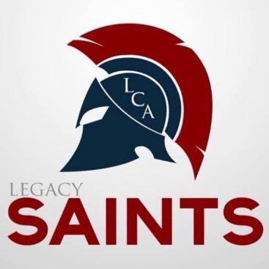

LCA Diploma Program

Legacy Christian Academy desires for every high school student to develop to their fullest potential academically. We encourage students to look beyond the minimum requirements for graduation and take a bigger challenge. One way we do this is to offer five diploma programs: General, College Prep, Advanced College Prep, Honors College Prep, and Advanced Honors College Prep.
The LCA standards exceed the minimum state requirements. Therefore, meeting the LCA requirements will earn students a College Prep Diploma. In rare situations, the principal may make an exception that meets the state standard but does not meet the LCA standard. In those cases, the student will receive a General Diploma.
Honors and Advanced Honors as well as GPA honors will be distinguished at graduation.

COLLEGE PREP DIPLOMA
To receive the College Prep Diploma:
- Minimum of 27 total credits.
- Minimum 80 Service-Learning hours
- Complete a week-long internship in the sophomore, junior, and senior years

ADVANCED COLLEGE PREP DIPLOMA
To receive the Advanced College Prep Diploma:
- Minimum of 29 credits
- Minimum 100 Service-Learning hours
- Complete a week-long internship in the sophomore, junior and senior years
- Minimum of 3.25 GPA
- Must get at least as far as Pre-Calculus in Math
- Student must have been at LCA for at least 2 years to be eligible

HONORS COLLEGE PREP DIPLOMA
To receive the Honors College Prep Diploma:
- Minimum of 29 credits including the following:
    - Honors Physical Science, Honors Biology, Honors Chemistry, and either Honors Anatomy, or Honors Physics
    - Honors Algebra I, Honors Algebra II, Honors Geometry, and Honors Pre-Calculus.
- Minimum of 100 Service-Learning hours
- Student can not miss more than 12 days in a school year.
- Complete a week-long internship in the sophomore, junior and senior years
- Minimum of 3.25 GPA
- Student must have been at LCA for at least 2 years to be eligible

ADVANCED HONORS COLLEGE PREP DIPLOMA
To receive the Advanced Honors Diploma:
- Minimum of 31 credits including the following:
Honors Physical Science, Honors Biology, Honors Chemistry, Honors Anatomy,
Honors Physics, Honors Algebra I and Honors Algebra II, Honors Geometry,
Honors Pre-Calculus, Honors Calculus.
- Minimum 120 Service-Learning hours
- Student cannot miss more than 12 days in a school year.
- Complete a week-long internship in the sophomore, junior and senior years
- Minimum of 3.50 GPA
- Student must have been at LCA for at least 2 years to be eligible

*Note: The Internship requirement will be to have completed an internship each year (grades10-12) that the student was enrolled at Legacy.
College Preparatory Diploma Advanced College Preparatory Diploma
27 Credits 29 Credits
4- Bible
4- English
4- History
5- Math
4- Science
1.5 PE
.5 Health
3 Language
1 Tech
1 Fine Arts
1 Elective
4- Bible
4- English
4- History
4- Math
3- Science
1.5 PE
.5 Health
2 Language
4 Electives

Honors College Prep Diploma Advanced Honors College Prep Diploma
29 Credits 31 Credits

4- Bible
4- English
4- History
5- Math
4- Science
1.5 PE
.5 Health
3 Language
1 Tech
1 Fine Arts
1 Elective

4- Bible
4- English
4- History
5- Math
5- Science
1.5 PE
.5 Health
4 Language
1 Tech
1 Fine Arts
1 Elective

Cumulative Diploma Honors
Recognized at Graduation
Cum Laude= 3.5 GPA*
Magna Cum Laude= 3.7 GPA*
Summa Cum Laude = 3.9 GPA*

*In order to be recognized for Honors, a student must have been at LCA for at least 2 years of high school.

